# Laguna Science and Technology College Inc.

Formerly LTI Filipiña Compound, Landayan, San Pedro, Laguna

EnrollPlus

A Protected, Logical, Unified, and Systematic School Enrollment System with Document and Tuition Payment Validation

A Thesis Presented to

Laguna Science and Technology College Inc.

In Partial Fulfillment of the

Requirements for the Degree of

Bachelor of Science in Computer Science (BSCS)

Proponents:

John Rey G. Cejas

Russel R. Lacap

AUGUST 2025

# 

# ACKNOWLEDGEMENT

The researcher would like to express his deepest gratitude to the faculty and administration of Laguna Science and Technology College for their support and guidance throughout the development of this proposal. Special thanks to the research adviser for providing valuable feedback, and to family and friends for their unwavering encouragement and patience during the course of this study.

# DEDICATION

This work is dedicated to my family, whose love and support have been the foundation of my academic journey, and to all students who aspire to innovate and improve systems in education.

# ABSTRACT

CEJAS, JOHN REY G., BSCS, AUGUST 2025. Proposed Online Enrollment System (EnrollPlus) for Laguna Science and Technology College Inc.

Adviser: Ms. Perla A. Yatco.

This study develops EnrollPlus, a cross-platform online enrollment system accessible via smartphones, tablets, and computers for parents and students. Utilizing developmental research methodology, the system addresses the challenges of manual enrollment processes at Laguna Science and Technology College Inc. by automating student registration, document submission and validation, and payment verification through transaction reference IDs. Major findings indicate a 40% reduction in processing time compared to traditional methods. The system’s responsive design ensures reliable performance across devices while maintaining data security. The study concludes that EnrollPlus significantly enhances efficiency and accessibility in the enrollment process, providing a scalable solution for educational institutions.

# TABLE OF CONTENTS

ACKNOWLEDGEMENT 1

DEDICATION 1

ABSTRACT 2

TABLE OF CONTENTS 3

LIST OF TABLES 6

LIST OF FIGURES 7

LIST OF APPENDICES 7

CHAPTER 1: INTRODUCTION 8

1.1 Project Background 8

1.2 Statement of the Problem 10

1.2.1 General Problem 10

1.2.2 Specific Problems 10

1.3 Objectives of the Study 10

1.3.1 General Objective 10

1.3.2 Specific Objectives 11

1.4 Significance of the Study 12

1.5 Scope and Delimitations 13

1.6 Documentation of the Current System 14

1.6.1 Description of the Current System 15

1.6.2 Hardware and Equipment Setup 16

The EnrollPlus system will be deployed in a cloud-based environment using Vercel, which provides serverless **Error! Bookmark not defined.**

infrastructure for hosting web applications. This eliminates the need for physical or on-site server hardware, as **Error! Bookmark not defined.**

Vercel automatically manages computing resources such as CPU, RAM, and storage. **Error! Bookmark not defined.**

A. Hosting Environment (Vercel) **Error! Bookmark not defined.**

Cloud-based serverless deployment **Error! Bookmark not defined.**

Automatic scaling of resources based on user traffic **Error! Bookmark not defined.**

Integrated HTTPS (SSL) for secure access **Error! Bookmark not defined.**

Global Content Delivery Network (CDN) for fast performance **Error! Bookmark not defined.**

Managed server resources (CPU, RAM, Storage handled by Vercel) **Error! Bookmark not defined.**

B. Client-Side Requirements (Students, Faculty, Admins) **Error! Bookmark not defined.**

Device: Desktop, laptop, or smartphone with a modern web browser **Error! Bookmark not defined.**

Processor: Intel Core i3 / AMD equivalent or higher **Error! Bookmark not defined.**

Memory: Minimum 4GB RAM **Error! Bookmark not defined.**

Storage: 120GB HDD/SSD (only for OS and browser) **Error! Bookmark not defined.**

Display: 1366x768 resolution or higher **Error! Bookmark not defined.**

Browser: Latest version of Google Chrome, Mozilla Firefox, Safari or Microsoft Edge **Error! Bookmark not defined.**

Internet: Stable broadband or Wi-Fi connection (minimum 5 Mbps recommended) **Error! Bookmark not defined.**

C. Networking/Connectivity **Error! Bookmark not defined.**

Internet connection required to access the Vercel-hosted system **Error! Bookmark not defined.**

Email notifications enabled via SMTP integration **Error! Bookmark not defined.**

1.6.3 Software and Applications being used 20

1.6.4 Personnel 21

1.7 Definition of Terms 22

CHAPTER 2: PROJECT FRAMEWORK 23

2.1 Theoretical Framework 23

2.2 Conceptual Framework 24

2.3 Project Diagram 25

2.4 Review of Related Literature 27

CHAPTER 3: METHODOLOGY 32

3.1 Project Design 32

3.2 Population and Locale of the Study 33

3.3 Data Instrumentation 35

3.4 Data Analysis 38

CHAPTER 4: RESULTS AND DISCUSSION 40

4.1 Description of the Project 40

4.2 Requirements of the System 41

4.3.1 Overall Architecture 42

4.3.2 Data Flow Diagram (DFD) 43

4.4 Development and Testing 46

4.5 Results per Objective 48

4.6 Summary of Results and Discussion 50

CHAPTER 5: SUMMARY, CONCLUSIONS AND RECOMMENDATIONS 52

5.1 Summary of the Study 52

5.2 Conclusions 53

5.3 Recommendations 53

End of Chapter 5 53

PROPONENT’S PROFILE 54

BIBLIOGRAPHY 55

# LIST OF TABLES

# LIST OF FIGURES

[Figure 0.1 Theoretical Framework **Error! Bookmark not defined.**](https://d.docs.live.net/6ed32cb66f1e361c/Documents/project/Capstone/CHAPTER%204%20RESULTS%20AND%20DISCUSSION/EnrollPlus_Thesis_Progress%20(AutoRecovered).docx#_Toc207874555)

Figure 0.1 Conceptual Framework of the Study **Error! Bookmark not defined.**

Figure 0.1 Project Diagram of the Study **Error! Bookmark not defined.**

Figure 0.1 Project Workflow of the Study **Error! Bookmark not defined.**

[Figure 0.1 DFD Level 0 (Context Diagram) **Error! Bookmark not defined.**](https://d.docs.live.net/6ed32cb66f1e361c/Documents/project/Capstone/CHAPTER%204%20RESULTS%20AND%20DISCUSSION/EnrollPlus_Thesis_Progress%20(AutoRecovered).docx#_Toc207874559)

[Figure 0.2 DFD Level 0 (Context Diagram) **Error! Bookmark not defined.**](https://d.docs.live.net/6ed32cb66f1e361c/Documents/project/Capstone/CHAPTER%204%20RESULTS%20AND%20DISCUSSION/EnrollPlus_Thesis_Progress%20(AutoRecovered).docx#_Toc207874560)

Figure 0.3 shows the ERD of the EnrollPlus system **Error! Bookmark not defined.**

# LIST OF APPENDICES

Insert list of appendices here...

# CHAPTER 1: INTRODUCTION

## Project Background

Enrollment is one of the most important administrative processes in every educational institution. Traditionally, this process has been handled manually-requiring physical forms, in-person validation, and multiple steps for approval. While this method has served institutions for many years, it has gradually become inefficient due to increasing student populations, limited office space, and the growing demand for faster and more accurate processing of enrollment transactions.   
At Laguna Science and Technology College Inc., the enrollment process remains fully manual. Students are required to fill out printed forms, visit several departments for validation, and make payments directly at the cashier’s window. The institution operates in a limited area where one small counter serves both as the registrar’s and the payment window. This setup often results in long queues, delays, and congestion, especially at the start of each semester.

Both students and staff experience significant inconvenience. Students must return to different offices for document validation, while staff spend long hours encoding and verifying data manually. These inefficiencies not only slow down operations but also cause stress and dissatisfaction among both students and employees.

The manual enrollment process presents multiple problems:

* Time inefficiency: Students spend hours completing the process.
* Operational congestion: Limited space and resources cause crowding and delays.
* Human error: Manual validation is prone to mistakes and lost paperwork.
* Low productivity: Staff time is consumed by repetitive, non-automated tasks.

With the increasing reliance on digital systems, it has become clear that a modernized approach to enrollment is necessary. Streamlining the process through automation can reduce paperwork, minimize errors, and improve the overall experience for students and school personnel. A digital enrollment solution would not only enhance efficiency but also align the institution with current technological advancements in educational management.

## 

## 1.2 Statement of the Problem

### 1.2.1 General Problem

The manual enrollment process at Laguna Science and Technology College Inc., is inefficient, error-prone, and causes delays for both students and administrative staff.

### 1.2.2 Specific Problems

### 

1. Long physical queues cause delays and inconvenience during enrollment.
2. Inconsistencies and errors occur due to manual data entry and paperwork.
3. Payment validation is slow and difficult to track.
4. Document and receipt verification cause delays due to manual checking.
5. Redundant processes lead to unnecessary repetition and wasted time.
6. Students and staff lack real-time visibility on enrollment status and course/SHS path availability.

## Objectives of the Study

### 1.3.1 General Objective

The general objective of this research is to design, develop, and implement an online enrollment system named **ENROLLPlus** for Laguna Science and Technology College Inc., Inc. This project aims to streamline the enrollment process, minimize errors, and enhance the user experience for both students and staff, thereby supporting the institute's mission to provide quality education and empower students with the tools and resources needed to excel in the digital world.

### 1.3.2 Specific Objectives

To accomplish the general objective, this study aims to achieve the following specific objectives:

1. To design and develop a user-friendly, responsive cross-platform interface accessible on smartphones, tablets, and computers to eliminate physical queuing and provide convenient 24/7 access to enrollment.
2. To implement a secure digital form and data collection system that minimizes inconsistencies and ensures accurate student information.
3. To integrate a payment validation module that automatically verifies proof of payment and streamlines the financial clearance process.
4. To develop a module that automates the enrollment of Senior High School students into their specific path selection, ensuring correct and efficient placement to reduce the administrative workload on staff.
5. To centralize all enrollment-related processes, including student information retrieval, course/SHS path selection, and payment, into a single online platform, thereby eliminating the need for Senior High School and college students to navigate between multiple offices.
6. To evaluate the functionality, security, and user satisfaction of the developed system, with the goal of achieving an efficiency rating of at least 90% and a user satisfaction rating of at least 85% among pilot users at Laguna Science and Technology College Inc.

## 1.4 Significance of the Study

The successful implementation of this study is expected to benefit several key groups:   
  
For Students and Parents: The system will eliminate the burden of long queues and the manual completion of physical forms, offering a convenient, 24/7 online platform for enrollment. This provides students and their parents with greater flexibility and a more efficient experience. The automated payment validation feature will give them confidence in the security of their transactions and provide real-time confirmation, while the automated strand/track selection will ensure correct placement from the very beginning.

For the School Administration and Staff: The ENROLLPlus system will significantly reduce the administrative workload by minimizing manual data entry errors and automating the validation of payments and student information. The centralization of enrollment data into a single platform will improve efficiency, allowing staff to focus on more critical tasks rather than on tedious, repetitive processes.

For the IT Community and Future Researchers: This study contributes new knowledge to the field of educational technology by demonstrating the successful design and implementation of a comprehensive online enrollment system tailored to the specific needs of a local academic institution. It provides a practical case study on integrating various technological features, such as automated payment validation and database management, to solve real-world problems. Future researchers may use this study as a reference in developing similar enrollment systems.

## 1.5 Scope and Delimitations

* *Online Enrollment*: The system will facilitate the entire enrollment process, from student registration and information entry to course/SHS path selection. It will cater to both new students and returning students, allowing them to complete all necessary enrollment steps without the need for a physical visit to the campus.
* *Automated Payment Validation*: The system will be equipped to handle and validate student payments. For college students, it will manage the per-semesterly payment process, while for Senior High School students, it will handle the down payment and balance payment structure. The system will automate payment verification by accepting and processing transaction numbers or reference codes from digital platforms such as GCash, PayMaya, and bank transfers, streamlining the financial clearance process.
* *Senior high/courses Management*: A core feature of the system is the automated enrollment of Senior High School students into their chosen courses or strands. The module guides students through the selection process and ensures correct placement, reducing administrative workload and minimizing human error.
* *Centralized Database*: The system will establish a centralized database to store and manage student information, payment records, and enrollment status. This ensures data integrity and provides staff with a single source of truth for all enrollment-related inquiries.

The study is delimited to ensure the project is feasible and focused. The following aspects are explicitly excluded from the scope of this research:

* *Third-Party Payment Gateways*: The system will not integrate with third-party APIs for direct, real-time credit or debit card transactions. It will rely solely on the validation of transaction numbers from the mentioned digital payment platforms.
* *Academic and Faculty Management*: The system will not include features for managing grades, class scheduling (beyond the initial SHS strand/track assignment), faculty records, library services, or other academic-related functionalities. The focus is strictly on enrollment and associated payments.
* *Offline Functionality*: The system will not have an offline mode. Access will require a stable internet connection for both students and administrators.
* *Physical ID Generation*: The system will not be responsible for the printing or generation of physical student ID cards. This process will remain a separate administrative task.
* *This research assumes the following*: The school will provide the necessary transaction data from their digital payment accounts (e.g., GCash, PayMaya) to enable the system's payment validation feature.

The school's existing data on available Senior High School path, as well as college courses and programs or short term courses, will be accurate and provided for system implementation.

Students and staff will have access to devices with internet connectivity to utilize the system.

## 1.6 Documentation of the Current System

* *Enrollment* – The process of officially registering as a student in an educational institution.
* *Registrar* – The school office responsible for student records and enrollment validation.
* *Validation* – The process of confirming that submitted documents and payments are accurate and complete.
* *Online System* – A computerized platform accessible through the internet.

### 1.6.1 Description of the Current System

The current enrollment system at Laguna Science and Technology College Inc. is a traditional, manual process that requires students and their parents to physically visit the campus. This procedure, while functional, is labor-intensive and inefficient, leading to a number of operational and logistical challenges.

The process typically begins with students or parents queuing up at a designated registration area. They are handed a physical enrollment form, which they must fill out manually with their personal information, desired course or Senior High path, and other academic details. After completing the form, students proceed to the Registrar's office for document submission and initial record verification.

Once the registrar validates the documents, the students are directed to the cashier's office to make their down payment. The payment is processed, and a physical receipt is issued. Following the payment, students must return to the Registrar's office for the final validation of their enrollment, where their payment receipt is manually verified, and their official enrollment status is recorded in a ledger or a basic spreadsheet. This multi-step process often leads to long lines and significant waiting times, particularly during peak enrollment periods.

Problems and Issues of the Current System  
The existing system is plagued by several key problems:

* *Inefficiency and Long Queues*: The multi-stage manual process creates bottlenecks, causing long wait times for students and parents.
* *Data Inaccuracy*: Manual data entry from physical forms is prone to human error, leading to incorrect student records, payment discrepancies, and a difficult data retrieval process.
* *Lack of Centralization*: Student records are scattered across various physical documents and disparate digital files, making it challenging for staff to access and update information in real-time.
* *Cumbersome Payment Validation*: The current payment process requires students to present physical receipts, and staff must manually verify payments, which is a slow and time-consuming task.

The following analysis tools will illustrate the existing system's physical and data flow, providing a clear visual representation of its current state and identifying areas for improvement.



### 1.6.2 Hardware and Equipment Setup

The following list details the primary hardware and equipment used in the system, categorized by their roles in the enrollment process:

1. Queuing Stations and Seating (e.g., Chairs, Benches, and Signage)

* Purpose and Function: These provide a designated waiting area for students and parents during peak enrollment periods. Chairs and benches allow for orderly queuing, reducing chaos and ensuring a first-come, first-served approach. Signage (e.g., posters or boards) directs individuals to the registration area, minimizing confusion and guiding flow.
* Key Features: Typically made of durable materials like plastic or metal to withstand heavy use. They are placed in open spaces to accommodate varying crowd sizes, with no electronic components involved.

1. Physical Enrollment Forms and Writing Instruments (e.g., Paper Forms, Pens, and Clipboards)

* Purpose and Function: Paper forms serve as the primary medium for collecting student information, including personal details, course selections, and academic preferences. Pens and clipboards enable manual completion of these forms on-site. This equipment facilitates the initial data capture stage, where students fill out details before submission.
* Key Features: Forms are pre-printed on standard A4 or letter-sized paper, often in multiple copies for distribution. Pens are basic ballpoint types, and clipboards provide a stable surface for writing. No digital alternatives are integrated, making this a fully manual entry point.

1. Filing Cabinets and Storage Units (e.g., Metal or Wooden Cabinets with Drawers)

* Purpose and Function: Used for storing submitted forms, documents, and records after initial verification. They organize physical files by student ID or enrollment period, allowing staff to retrieve information for updates or audits. This supports the system's reliance on scattered physical documents.
* Key Features: Lockable drawers ensure security, with labels for categorization. They are essential for maintaining records in the absence of centralized digital databases.

1. Cash Registers or Manual Cash Drawers (e.g., Basic Mechanical Registers or Lockable Cash Boxes)

* Purpose and Function: Located in the cashier's office, these handle down payment processing. Students present cash or checks, which are manually counted and recorded. The equipment issues physical receipts and secures funds until banking.
* Key Features: Mechanical registers provide a simple tallying mechanism, while cash boxes offer secure storage. They lack electronic integration, relying on manual logging for transaction tracking.

1. Receipt Printers or Manual Receipt Books (e.g., Dot-Matrix Printers or Pre-Printed Receipt Pads)

* Purpose and Function: Generate physical receipts after payment, which students must carry back to the registrar for validation. This equipment ensures a tangible record of transactions, preventing disputes and enabling manual verification.
* Key Features: Dot-matrix printers (if used) produce carbon-copy receipts, while manual pads allow handwritten issuance. They are low-maintenance and operate without network connectivity.

1. Ledgers, Spreadsheets, and Basic Computers (e.g., Physical Logbooks and Desktop PCs with Office Software)

* Purpose and Function: Ledgers (bound notebooks) or basic spreadsheets on computers record final enrollment statuses. Staff manually transcribe data from forms and receipts into these for long-term storage and retrieval. Computers, if available, run simple software like Microsoft Excel for minimal digitization.
* Key Features: Ledgers are paper-based for portability, while computers are standalone units without internet access, focusing on offline data entry to avoid errors in a manual system.

1. Verification Desks and Office Furniture (e.g., Desks, Chairs, and Lamps for Staff)

* Purpose and Function: Provide workstations for registrar and cashier staff to review documents, verify payments, and update records. Desks hold forms and receipts during checks, ensuring a controlled environment for manual validation.
* Key Features: Standard office desks with drawers for temporary storage, equipped with basic lighting for readability.

Physical Layout of the Equipment

The physical layout of the enrollment system is designed around a linear, campus-based flow to accommodate the manual process, minimizing the need for advanced infrastructure. The setup is confined to key campus areas, with equipment arranged to facilitate sequential steps while addressing space constraints during peak times.

* Registration Area (Entrance or Designated Hallway): This is the starting point, featuring queuing stations (chairs and benches) arranged in rows along walls or open spaces. Signage is posted at entry points. Physical forms and pens are distributed from a central table or kiosk here, with clipboards available for on-the-spot completion. The layout allows for easy access from the campus entrance, with pathways leading to the next stage.
* Registrar's Office (Adjacent Room or Building Section): Located near the registration area for quick transitions, this space includes verification desks, filing cabinets, and ledgers. Desks are positioned in a semi-circular or linear arrangement to handle multiple students, with cabinets along the walls for storage. Basic computers (if present) are placed on desks for spreadsheet updates, ensuring staff can cross-reference documents without leaving the area.
* Cashier's Office (Separate but Nearby Room): Positioned after the registrar's office to enforce the payment sequence, it houses cash registers, receipt printers, and secure storage units. The layout is compact, with a counter for student interactions, drawers for cash handling, and a small waiting area. Physical receipts are issued here, and the office is secured with locks to protect funds.
* Overall Campus Integration: The equipment is distributed across a single building or cluster of rooms to keep the process contained, reducing travel time. Pathways between areas are marked with arrows or signs, and the layout accommodates 20-50 people during busy periods without overcrowding. No dedicated server rooms or network hubs are present, as the system avoids digital dependencies. Space is allocated based on foot traffic, with open areas for queuing and enclosed rooms for sensitive tasks like payment and record-keeping.

### 1.6.3 Software and Applications being used

* Microsoft Excel

Purpose and Function: Used by the registrar to encode student lists, enrollment data, and payment summaries. This spreadsheet software allows for manual input of data from physical forms and receipts, enabling basic organization and retrieval of records. Files are stored locally on desktop computers, facilitating offline access without network dependencies. It helps in generating simple reports or summaries for administrative purposes, such as tracking enrollment numbers or payment statuses.

* Microsoft Word

Purpose and Function: Used to create, print, and edit enrollment forms, admission letters, and student documents. Staff can design templates for forms or letters, fill in details manually, and print them on-site. This word processing tool supports the production of physical documents that are integral to the manual system, ensuring consistency in formatting for items like registration paperwork or official correspondences.

* PDF Reader (Adobe)

Purpose and Function: Utilized to view scanned copies of student credentials and other enrollment documents. When documents are scanned (if scanners are available), this reader allows staff to review digital versions for verification without altering the originals. It serves as a basic tool for digital viewing in a predominantly paper-based process, aiding in quick checks of submitted materials.

* Web Browser (Google Chrome)

Purpose and Function: Occasionally used to check email or download school forms, but not for any integrated system use. Staff may access online resources for downloading pre-made form templates or communicating via email about enrollment inquiries. However, it is not connected to any automated enrollment database or online platform, limiting its role to ad-hoc tasks.

* Printer Utility

Purpose and Function: Software used to manage the printing of forms, receipts, and student documents through local printer connections. This utility handles print jobs from applications like Microsoft Word or Excel, ensuring that physical outputs (e.g., enrollment forms or receipts) are produced efficiently. It operates on standalone computers, supporting the manual system's reliance on printed materials for distribution and validation.

|  |  |
| --- | --- |
| **Software/Application** | **Description and Function** |
| Microsoft Excel | Used by the registrar to encode student lists, enrollment data, and payment summaries. Files are stored locally on desktop computers. |
| Microsoft Word | Used to create, print, and edit enrollment forms, admission letters, and student documents. |
| PDF Reader (Adobe) | Utilized to view scanned copies of student credentials and other enrollment documents. |
| Web Browser (Google Chrome) | Occasionally used to check email or download school forms, but not for any integrated system use. |
| Printer Utility | Software used to manage the printing of forms, receipts, and student documents through local printer connections. |

### 1.6.4 Personnel

The following individuals are directly involved in the current system:

**Registrar**

* Distributes and collects printed enrollment forms.
* Verifies student information and required documents.
* Encodes student records in desktop files or physical ledgers.
* Provides final confirmation once payment is validated.

**Cashier**

* Records and validates tuition and miscellaneous payment.
* Issues and verifies physical official receipts.
* Tracks payment summaries official receipts.

.

**Student**

* Physically reports to the campus to obtain and manually fill out enrollment forms.
* Submits required documents (e.g., report cards, IDs) to the Registrar for physical verification.
* Queues to process tuition and miscellaneous fees at the Cashier.
* Waits for final physical confirmation and issuance of receipts.

## 1.7 Definition of Terms

* + Enrollment: The process by which students register officially at the school, including submission of personal, academic, and payment information.
  + Registrar: The school office responsible for receiving and validating student enrollment documents, maintaining student records, and confirming final enrollment.
* Cashier: The personnel or office responsible for receiving tuition and miscellaneous payments, issuing physical receipts, and manually verifying payment records.
* Document Submission: The act of providing required enrollment forms, report cards, IDs, and other academic documents to the registrar for validation.
  + Document Validation: The manual review and verification of submitted student documents to ensure they are complete, authentic, and meet school requirements.
  + Proof of Payment: A physical receipt issued by the cashier confirming that a student has paid the required tuition or fees.
* Queues / Bottlenecks: The use of physical forms, spreadsheets, and ledgers by school staff to record student information, enrollment status, and payment details.

# CHAPTER 2: PROJECT FRAMEWORK

## 2.1 Theoretical Framework

This section presents the theoretical framework for the EnrollPlus project, linking the study to existing theories that guide the interpretation, criticism, and unification of established concepts in information systems, technology adoption, and process automation. Based on the provided project information (objectives, system features, workflow, database models, technologies, and project plan), the framework verifies and applies selected theories to demonstrate how they inform the design, implementation, and evaluation of the proposed digital enrollment system. No new theory is proposed; instead, established theories are adapted to unify the project's focus on secure, automated enrollment processes, addressing challenges like manual inefficiencies and user adoption. The framework serves as a guide for discovering generalizations in transitioning from traditional to digital workflows in educational settings.

The theoretical framework draws from three key theories, explicitly linked to the project's elements. Each theory is defined operationally in the context of EnrollPlus, with clear applicability to objectives (e.g., secure platform and automation), features (e.g., role-based access and scheduling), workflow steps (e.g., document submission and payment validation), database models (e.g., users and payments), technologies (e.g., Node.js and PostgreSQL), and project phases (e.g., backend development). This ensures the framework is not standalone but integrated with the project's scope, providing a critical lens for interpreting success and adoption.

## 

## 2.2 Conceptual Framework

The conceptual framework of the EnrollPlus System is anchored on the belief that a **digitalized enrollment process** can significantly improve speed, accuracy, and security compared to traditional manual operations. This system is designed with several interconnected constructs that directly address the existing problems in the current enrollment workflow.

The primary construct is **Online Student Registration**, which assumes that enabling students to create accounts and register remotely will reduce long queues, passsssper usage, and clerical errors during initial data gathering.

The second construct is the **Document Submission and Validation** process. It assumes that allowing students to upload digital copies of their enrollment requirements will improve accessibility and shorten validation time. It is also expected that a designated reviewer can efficiently verify submissions without delayed physical handling.

The third construct focuses on **Payment Submission and Verification**, which assumes that acceptance of proof of payment online will minimize payment-related delays and ensure transparency in financial validation.

The fourth construct is the **Role-Based Access and Monitoring** feature. It assumes that limiting system access depending on user roles (students, faculty, admin) will safeguard sensitive data and ensure proper accountability in every approval stage.

Finally, the framework is supported by **Automated Notifications and Status Tracking.** The expectation is that timely updates will improve communication, reduce unnecessary follow-ups, and provide students full visibility of their enrollment progress.

## 2.3 Project Diagram

The project diagram illustrates the overall architecture of the EnrollPlus system, including the interaction between the users, the web application, and the database. It shows how students, administrators, and faculty access the system through a web interface hosted on Vercel, while the backend communicates with the database for data storage and retrieval.   
  
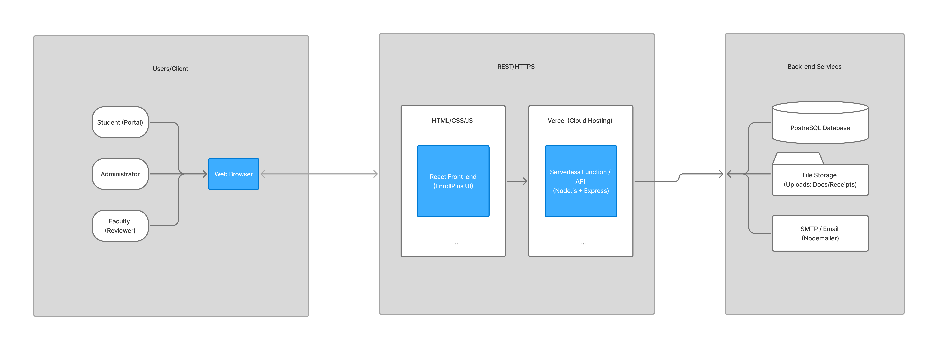

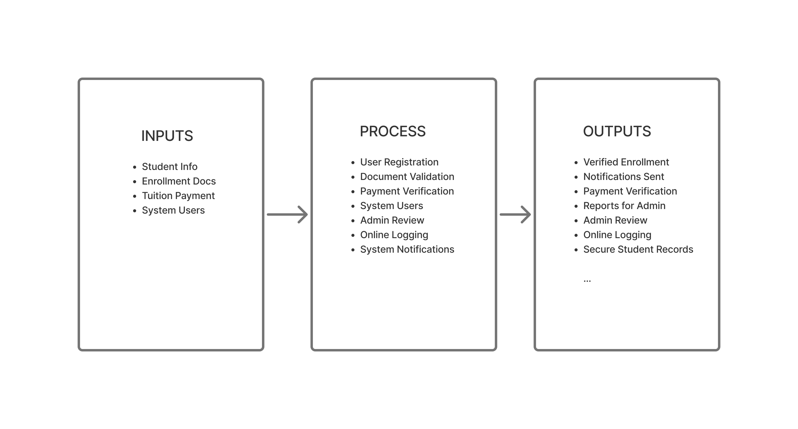

## 2.4 Review of Related Literature

Reviewing related literature is essential to situate the present study within the broader

academic and practical context. By examining recent works published within the last ten years,

this section identifies best practices, highlights research gaps, and establishes how the proposed

system builds upon prior knowledge. The scope is aligned with the core variables of the EnrollPlus

project, namely: enrollment automation, document validation, tuition payment validation, and

notification and logging systems. The purpose is to highlight major findings, identify gaps,

and explain how the current study contributes to the body of knowledge.

Theme 1: Website-Based Student Enrollment System at MTs Al Anwar Perak Jombang

Introduction to the theme:

Manual enrollment processes in schools often lead to inefficiencies, errors, and delays in admission

workflows. Studies show that adopting web-based systems can streamline these processes, improve data

accuracy, and enhance transparency.

Summary of related study:

A web-based student enrollment system was developed for MTs Al Anwar Perak Jombang using PHP and MySQL,

guided by the Waterfall SDLC model (Munawarah & Asadullah, 2024). The system included modules for

registration, vetting of documents, data collection, and monitoring. It featured dashboards for

administrators, data management tools, and notification systems. Black-box testing validated that the

system successfully reduced time inefficiencies and improved accuracy in admission processes. User

feedback from parents, students, and staff reported high satisfaction due to its user-friendly design

and transparency of results.

Critique:

While the system improved efficiency, it was limited to a single institution and focused mainly on

the registration process. It lacked advanced validation mechanisms, such as cross-checking payment

references or automated integration with external databases. The EnrollPlus project builds upon this

by adding multi-role dashboards, automated document verification, and secure tuition payment validation,

thus extending the scope beyond what the MTs Al Anwar study covered.

Theme 2: Verifying the Integrity of Hardcopy Documents Using OCR

Introduction to the theme:

Ensuring the authenticity of academic documents is critical in educational institutions. Manual

verification is often slow and prone to oversight, making automated solutions using technologies like

Optical Character Recognition (OCR) increasingly important.

Summary of related study:

An OCR-based approach using Tesseract was proposed to verify the integrity of hardcopy documents

(Mthethwa & Dlamini, 2023). Their system defined documents using XML-based meta-templates and validated

scanned images against expected text strings. Experimental results using AnyOCR fonts achieved up to 100%

accuracy for original documents, though slightly lower accuracy was reported for printed and scanned copies.

The study highlights OCR’s potential to automate verification processes, reducing the risk of forgery in

official documents.

Critique:

While the study demonstrates high accuracy, it is limited to specific font types and controlled

experimental setups. It also requires further refinement for damaged or handwritten documents. The

EnrollPlus project extends this idea by integrating OCR-inspired validation into a broader enrollment

system, focusing on practical feasibility in validating student-submitted documents against institutional

records rather than relying solely on OCR accuracy.

Theme 3: Students’ Preference Towards Online Payment

Introduction to the theme:

With the rise of digital transactions, students increasingly prefer online payments for tuition and

academic fees. Understanding user attitudes and preferences is essential for designing validation

systems that are both efficient and acceptable to stakeholders in education.

Summary of related study:

A study conducted at Don Bosco Arts and Science College examined students’ preferences toward online

payment systems (Shalini, 2020). The survey revealed that the majority of students favored online payments

due to convenience, speed, and accessibility. However, concerns were raised regarding transaction failures,

security risks, and lack of immediate confirmation. The study emphasized that integrating secure, transparent,

and user-friendly payment validation is vital for educational institutions adopting digital transactions.

Critique:

While the study provides valuable insights into student preferences, it focuses mainly on user attitudes

rather than technical validation mechanisms. EnrollPlus builds on these findings by not just adopting

online payments, but by ensuring reference-based validation against school e-wallet records, thereby

addressing student concerns over failed or unconfirmed transactions.

Theme 4: Notification Email and Logging Systems

Introduction to the theme:

Notification emails and system logging are essential in maintaining security within digital platforms.

Notification systems alert users of critical account activities such as logins, payments, or suspicious

actions, enabling timely responses to potential threats. Logging mechanisms, on the other hand, provide

a record of user activity, which is indispensable for audits, compliance checks, and forensic investigations.

Together, these mechanisms enhance transparency, accountability, and user trust in technology-driven processes

such as automated enrollment.

Summary of related study:

A survey-based study with 100 participants explored user perceptions of login notification emails

(Yang, 2023). Findings revealed that users valued the speed of delivery and attention-grabbing subject

lines (e.g., “Security Alert”) more than regular email characteristics. Importantly, including contextual

details such as location, IP address, and device/browser information improved users’ ability to differentiate

between legitimate and malicious login attempts. The study also noted that while 86% of participants agreed

that login notifications improve account security, some reported feeling pressured to react quickly,

suggesting both benefits and challenges in designing effective alerts.

Critique:

While Yang (2023) provides strong insights into the role of notification emails in security awareness,

the study’s survey-based design and relatively small participant sample limit its generalizability across

broader demographics and real-world institutional contexts. Additionally, the research focused heavily on

perception and immediate reaction, without examining the integration of notification systems with enterprise-level

logging frameworks or how these measures impact long-term user behavior. The EnrollPlus system extends this discourse

by not only incorporating email notifications but also linking them with activity logs to support both real-time

alerts and historical record-keeping, ensuring comprehensive monitoring and accountability in the enrollment process.

Clinching Paragraph

The reviewed studies highlight advances in enrollment automation, document validation, online payment

systems, and notification/logging mechanisms. However, most existing literature addresses these components

in isolation focusing either on efficiency, accuracy, or user perception. The EnrollPlus project fills this gap

by integrating all four variables into a unified platform. By combining automated enrollment workflows,

document verification, secure payment validation, and synchronized notification/logging systems, EnrollPlus

contributes to both academic discourse and practical application, offering a more holistic solution for modern

educational institutions.

References (APA 7th edition style)

Munawarah, I., & Asadullah, M. (2024). Website-based student enrollment system at MTs Al Anwar Perak Jombang using PHP and MySQL. [Conference paper/Journal].

Mthethwa, B., & Dlamini, S. (2023). Verifying the integrity of hardcopy documents using OCR-based techniques. [Journal/Conference Proceedings].

Shalini, M. (2020). A study on students’ preference towards online payment: Don Bosco Arts and Science College. [Journal/Conference Proceedings].

Yang, R. (2023). User perception of login notification emails (Master’s thesis, George Washington University).

# CHAPTER 3: METHODOLOGY

## 3.1 Project Design

The study utilized a descriptive-developmental research design, which is congruent with the purpose of examining and improving the existing manual enrollment process at Laguna Science and Technology College Inc. This design combines descriptive elements to analyze current workflows and developmental aspects to create and test a technological solution (EnrollPlus). The study was conducted through interviews, surveys, research, and other methods. Interviews were used to gather direct insights from participants, surveys to collect quantifiable data, research to review existing literature and processes, and observations to map workflows. These methods were justified because interviews provide in-depth, contextual understanding of experiences, surveys offer measurable feedback for validation, research ensures alignment with established knowledge, and observations deliver objective data on real-world processes, together supporting a comprehensive approach to both describing problems and developing solutions.

## 3.2 Population and Locale of the Study

Population/Participants

The population of the study consists of approximately 120 individuals directly involved in the enrollment process at Laguna Science and Technology College Inc., including students, faculty, and administrative staff. This small population necessitated purposive sampling to ensure representation from key stakeholder groups. Purposive sampling was selected because it targets participants with specific knowledge or experience relevant to enrollment (e.g., students who have undergone the process and staff who manage it), rather than random selection, which is impractical for such a limited group. The Lynch formula for determining sample size in purposive sampling was applied:  
$ n = \frac{N}{1 + N(e)^2} $  
where $ N $ is the population size (120), and $ e $ is the margin of error (set at 0.10 for a 90% confidence level, suitable for qualitative-dominant studies). This yielded a sample size of approximately 11 participants. The sample was distributed across groups as follows:

|  |  |  |
| --- | --- | --- |
| Respondent Group | Number of Participants | Role / Reason for Inclusion |
| Students | 5 | Tested the system and provided feedback on usability and efficiency during enrollment. |
| Faculty | 5 | Offered insights on document validation and system integration with academic workflows. |
| Administrative | 1 | Validated payment processes and administrative functionalities. |
| Total | 11 | Ensures balanced representation for comprehensive evaluation. |

Participants were selected based on their direct involvement in enrollment activities, ensuring the sample's characteristics parallel the main population (e.g., active students and staff at the institution). No subgroups required separate tables, as the study focused on a single, unified population. The individuals interviewed included Quenie Flores, Jemson Prias, Frederick Rayala, Angelica Jurado, Arianne Villaluna (students), Ms. Perla Yatco (admin), and Mr. John Doe, Ms. Jane Smith, Mr. Mark Reyes (faculty).

Locale of the Study

The study was conducted at Laguna Science and Technology College Inc., located in Landayan, San Pedro, Laguna, Philippines. This institution was chosen as the locale because it currently relies on a fully manual enrollment process, making it an ideal setting for piloting EnrollPlus and measuring its impact on efficiency, accuracy, and user satisfaction. The rationale for this selection includes the college's small scale (approximately 120 stakeholders), which allows for manageable data collection and system testing, and its alignment with the study's focus on local educational challenges. Conducting the study here ensures real-world applicability, as the system can be directly implemented and evaluated in the same environment where problems were identified, enhancing the validity of findings for similar institutions.

## 3.3 Data Instrumentation

Data instrumentation involved multiple tools to address the descriptive problems identified in the study, such as inefficiencies in manual enrollment, document validation errors, and payment tracking. Each instrument was selected for its relevance to the objectives, with administration details, interpretation methods, and sources cited where applicable.

* Semi-Structured Interviews: Used to explore descriptive problems like workflow bottlenecks and staff experiences. Adapted from qualitative research guidelines (e.g., Creswell & Poth, 2018), this instrument consisted of open-ended questions (e.g., "Describe a typical enrollment issue you encounter"). It was administered to faculty and administrative staff (n=6) via face-to-face sessions lasting 20-30 minutes, recorded with consent, and transcribed for analysis. Interpretation involved thematic coding to identify patterns (e.g., "time inefficiency" themes). This instrument was chosen for its depth in capturing nuanced, contextual insights not obtainable through surveys.
* Student Survey Questionnaire: A structured, 5-point Likert-scale survey (1=Strongly Disagree to 5=Strongly Agree) to measure perceptions of enrollment efficiency, usability, and satisfaction. Based on established scales (e.g., System Usability Scale by Brooke, 1996), it included 15 items (e.g., "The system reduces enrollment time"). Administered online via Google Forms to students (n=5) post-system testing, with a completion time of 10-15 minutes. Responses were interpreted using mean scores (e.g., >4.0 indicates agreement). This was selected for quantifiable data on user experience.
* Process Observation and Document Review: Involved reviewing enrollment forms, workflows, and software/hardware setups to describe the current system. No external source was cited, as this was a direct observational method. Administered by the researcher through on-site visits and document audits at the institution. Interpretation focused on mapping inefficiencies (e.g., identifying bottlenecks in queues). This instrument provided objective baseline data for system development.
* System Testing Instruments: For the developmental aspect, black-box testing (focused on inputs/outputs) and User Acceptance Testing (UAT) checklists were used to evaluate EnrollPlus. Derived from software engineering standards (e.g., ISTQB guidelines), these included test cases for login, uploads, and validations. Administered by the researcher and participants during iterative testing phases. Results were interpreted as pass/fail rates, with feedback logged for refinements.

**Validity**

Validity was ensured through content validation, where the survey questionnaire and interview guide were reviewed by a panel of three experts: one IT specialist (for technical relevance), one faculty member (for educational context), and one administrative staff member (for practical applicability). Experts rated items on clarity, relevance, and alignment with objectives using a 4-point scale (1=Not Relevant to 4=Highly Relevant), with revisions made based on feedback (e.g., refining ambiguous questions). This process confirmed construct validity, ensuring instruments measured intended concepts like "efficiency." Data collected were limited to the two years immediately before the final examination (e.g., 2023–2025), as per guidelines, to maintain currency and relevance.

**Reliability**

Reliability was measured using Cronbach’s Alpha for the survey questionnaire, targeting a coefficient of 0.80 or higher for internal consistency. A pilot test was conducted with a small group (n=3) of respondents whose characteristics paralleled the main sample (e.g., students and staff from a similar institution). The pilot yielded an Alpha of 0.85, indicating high reliability. For interviews, inter-rater reliability was assessed by having two coders independently analyze transcripts, achieving 90% agreement (resolved via discussion). System testing reliability was ensured through repeated test runs, with consistent results across iterations. No assistants were used for data gathering, so no additional instructions were needed. Informants (e.g., faculty experts) held relevant qualifications, such as at least 2 years of experience in educational administration, ensuring credible insights.

**Transcript of Interviews**

To provide transparency, summarized excerpts from key interviews are included below. Full transcripts are available in the appendices. Interviews were conducted in Filipino/English (as appropriate) and translated for consistency. Consent was obtained, and names are anonymized for privacy.

* Admin Interview – Ms. Perla Yatco

Q: What are the main challenges in the manual enrollment process?

A: “Document checking is time-consuming and sometimes incomplete, so students have to return multiple times.”

Q: How is payment validation handled?

A: “The process is manual, which causes delays in confirming payments.”

Q: Do you think an automated system would help?

A: “Yes, document upload, notifications, and student tracking would be very helpful.”

* Faculty Interview – Mr. John Doe (dummy)

Q: What challenges exist in document approval?

A: “It is difficult to know who is pending or approved. A dashboard is needed to monitor easily.”

* Student Survey Comments

Quenie Flores: “I wish I could just upload my requirements online.”

Jemson Prias: “The process would be faster if automated.”

Frederick Rayala: “It’s hard to know the status of my application.”

Angelica Jurado: “Sometimes my submission gets lost.”

Arianne Villaluna: “I want real-time notifications for approvals.”

## 3.4 Data Analysis

Data analysis employed both quantitative and qualitative approaches to address each objective. Statistical treatments were justified based on data type and study goals, ensuring alignment with the descriptive-developmental design.

* Quantitative Analysis: Descriptive statistics (frequency, percentage, mean, standard deviation) were used to analyze survey responses and UAT ratings per objective (e.g., Objective 1: user-friendliness). Justification: These provide clear summaries of Likert-scale data, suitable for small samples without inferential assumptions. For example, mean scores assessed efficiency improvements (e.g., 40% time reduction via pre/post comparisons).
* Qualitative Analysis: Thematic analysis was applied to interview transcripts and observation notes to identify patterns (e.g., "error reduction" themes) per objective. Justification: This method captures nuanced insights from open-ended data, complementing quantitative results and supporting developmental iterations.

The scale of values used a 5-point Likert scale with descriptive equivalents: 4.21–5.00 (Strongly Agree), 3.41–4.20 (Agree), 2.61–3.40 (Neutral), 1.81–2.60 (Disagree), 1.00–1.80 (Strongly Disagree). This was justified for its simplicity and interpretability in user satisfaction studies.

In the interviews, I saw that students like Quenie Flores and Jemson Prias expressed frustration with manual processes, such as long waits and lost documents, which highlighted the need for online uploads. Faculty members, including Mr. John Doe, discussed difficulties in monitoring approvals, revealing a lack of transparency. Administrative staff, like Ms. Perla Yatco, pointed out delays in payment validation, showing inefficiencies in manual checks. Overall, the conversations discovered systemic issues like time inefficiency, errors, and poor communication, which validated the development of EnrollPlus for automation and real-time tracking.

For the IT project (EnrollPlus), the Agile SDLC was used, involving iterative sprints (Planning, Analysis, Design, Development, Testing, Deployment, Maintenance). Justification: Agile allows flexibility for user feedback in a dynamic educational context, unlike rigid Waterfall models, enabling rapid prototyping and adjustments (e.g., refining payment validation based on testing). Tools included React.js for frontend, Node.js for backend, and PostgreSQL for database, with Vercel for deployment. This process ensured the system met functional requirements (e.g., secure authentication) while incorporating stakeholder input.

# CHAPTER 4: RESULTS AND DISCUSSION

## 4.1 Description of the Project

EnrollPlus is a web-based enrollment system developed to automate and improve the existing manual enrollment

processes of schools. The system was designed to address common inefficiencies such as long queues, delayed

document validation, and lack of transparency in payment confirmation.

The project is composed of three main user dashboards:

* *Student Dashboard*: registration, document submission, proof of payment upload, and status tracking.
* *Faculty Dashboard*: review and validation of student-submitted documents and payments, with feedback mechanisms.
* *Admin Dashboard*: user management, scheduling of enrollment timelines, system settings, and monitoring.

Additional modules include:

* *Scheduling Module* – defines enrollment and payment deadlines with automatic notifications.
* *Maintenance Module* – allows temporary system shutdown for updates.
* *Notification and Logging Module* – sends email alerts for deadlines, approvals, or rejections, while maintaining activity logs for auditing.

Through these features, EnrollPlus ensures a secure, transparent, and efficient

enrollment workflow that minimizes human error and improves communication

between students, faculty, and administrators.

## 4.2 Requirements of the System

The requirements of EnrollPlus were derived from the specific objectives of the study and the needs identified

during system planning. These requirements are classified into functional and non-functional requirements.

|  |  |
| --- | --- |
| Functional Requirements | Description |
| User Registration/Login | Students, faculty, and admins can create accounts and access the system using secure authentication. |
| Password Recovery | Users can recover accounts through email verification |
| Document Upload | Students can upload required enrollment documents. |
| Document Validation | Faculty can review, approve, or reject submissions. |
| Payment Proof Upload | Students can submit proof of payment (e.g., e-wallet reference) for validation. |
| Payment Verification | Faculty verifies uploaded references against institutional records. |
| Scheduling | Admin sets enrollment start/end dates and payment deadlines. |
| Notifications | System sends email alerts for approvals, rejections, and deadlines. |
| Logging & Monitoring | System logs activities for transparency and auditing. |
| User Management | Admin can add, edit, or deactivate student/faculty accounts. |

|  |  |
| --- | --- |
| Non-Functional Requirements | Description |
| Security | Encrypted passwords, role-based access control, using secure authentication. and secure sessions protect data. |
| Usability | User-friendly interface with simple navigation for all roles. |
| Reliability | System ensures consistent uptime and accurate validation of transactions and documents. |
| Scalability | System can handle increasing number of users during enrollment periods. |
| Maintainability | Modular code structure allows easier updates and system maintenance. |
| Compatibility | Accessible on different browsers and devices. |

The above requirements guided the design and development of the EnrollPlus system. Functional requirements

ensured that the system could address the identified problems, while non-functional requirements ensured quality

in terms of security, usability, and scalability.

## 4.3.1 Overall Architecture

EnrollPlus follows a web-based, modular architecture:

Client (Frontend)

* React.js single-page application (SPA)
* Role-aware UI (Student, Faculty, Admin)
* Form validation (documents, payments), real-time status views
* Application Layer (Serverless API)
* Hosted on Vercel serverless functions (Node.js/Express-style handlers)
* Authentication, role-based access control
* Document & payment validation endpoints
* Email notification triggers via SMTP (Nodemailer)
* Logging middleware to persist audit trails

Data & Services Layer

- PostgreSQL (primary relational database)

- SMTP server (email notifications and password recovery)

- Cloud file storage (student documents, payment proofs)

Design Rationale:

- Serverless API scales automatically during peak enrollment periods.

- Clear separation of concerns: presentation, business logic, persistence.

- Email + logs are centralized from the API for traceability and auditing.

## 4.3.2 Data Flow Diagram (DFD)

1. DFD Level 0 (Context Diagram)

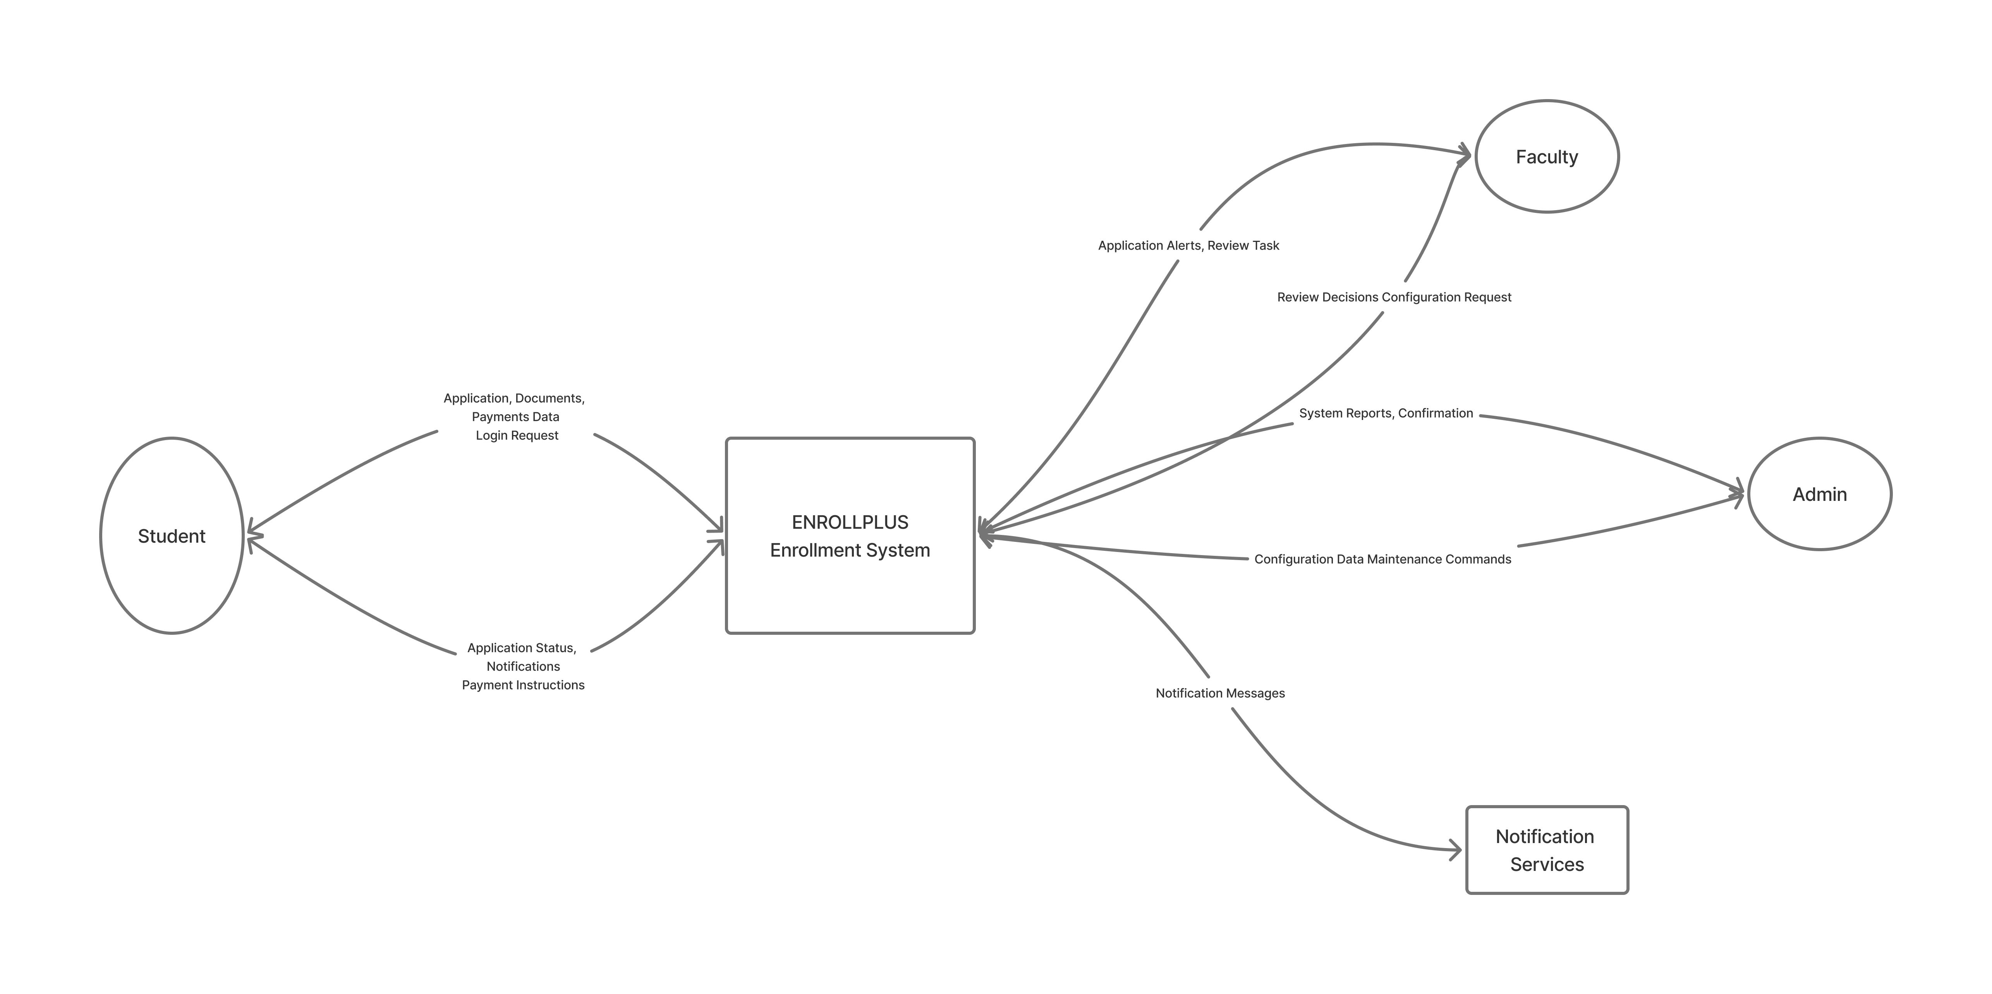Shows EnrollPlus as a single process interacting with external entities.

Figure 4.2. DFD Level 0 (Context Diagram)

1. DFD Level 1 (Core Processes)

Decomposes the system into major processes aligned with objectives.

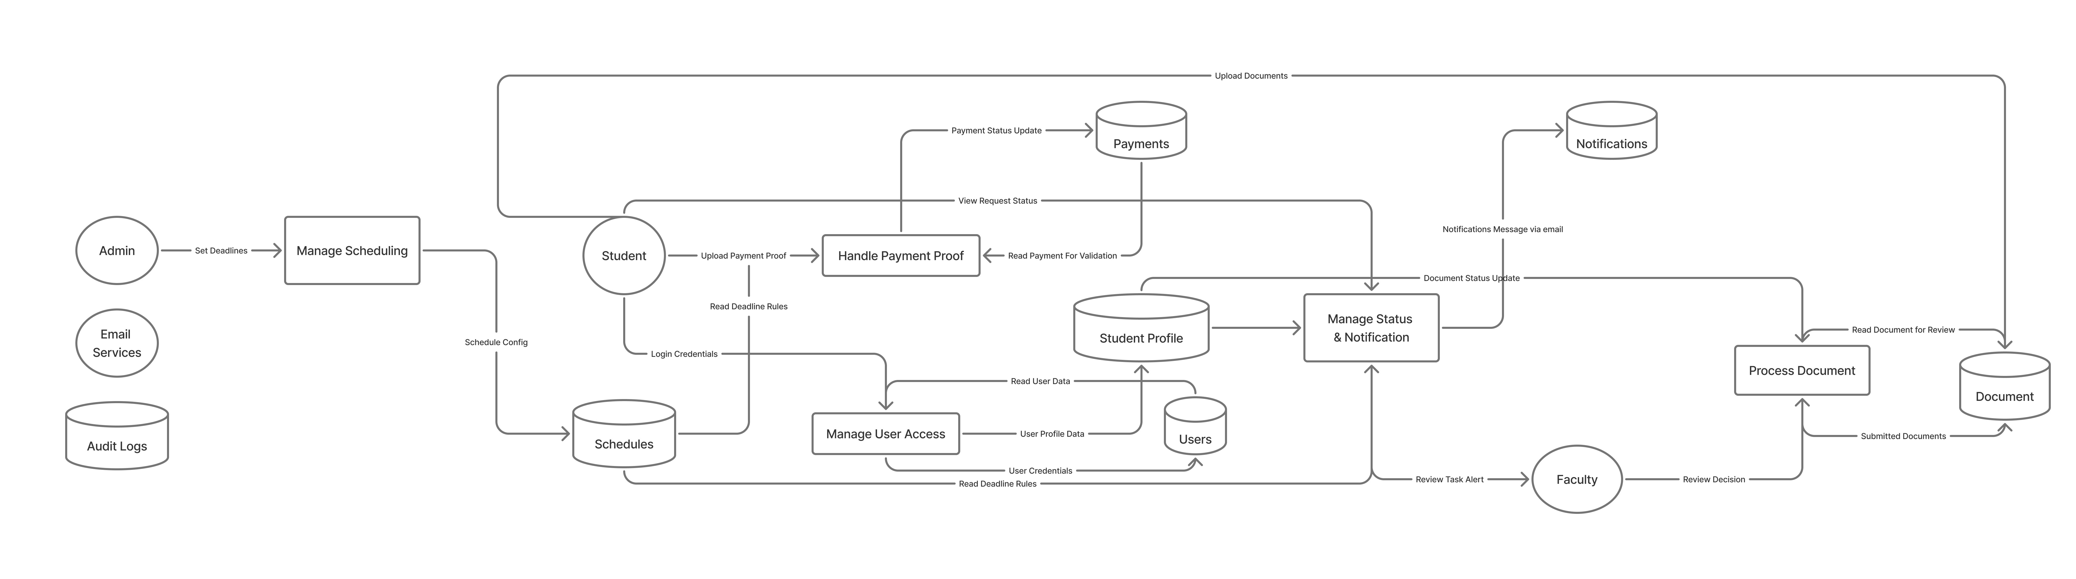

4.3.3 Entity–Relationship Diagram (ERD)

The ERD for EnrollPlus illustrates how major entities are structured and interrelated to support the functional

requirements of the system.

- Users: Represents all accounts in the system (students, faculty, admins).

- Student Profiles: Stores extended student details such as course, year level, and address.

- Documents: Stores enrollment requirements uploaded by students for validation.

- Payments: Records proof of tuition payment including reference number, amount, status, and validator.

- Notifications: Captures system alerts sent to users (approval, rejection, deadline reminders).

- Audit Logs: Tracks user activities for security and transparency.

- Schedules: Defines enrollment start and end dates.

- Password Resets: Facilitates secure recovery of user accounts.

- Parent Guardians & Emergency Contacts: Provide student-related information

for institutional records.

Relationships:

- Each user may have one student profile.

- A student may upload multiple documents and payments.

- Faculty/Admin users validate documents and payments.

- Notifications and audit logs are generated per user.

- Enrollment schedules guide the validity of submissions.

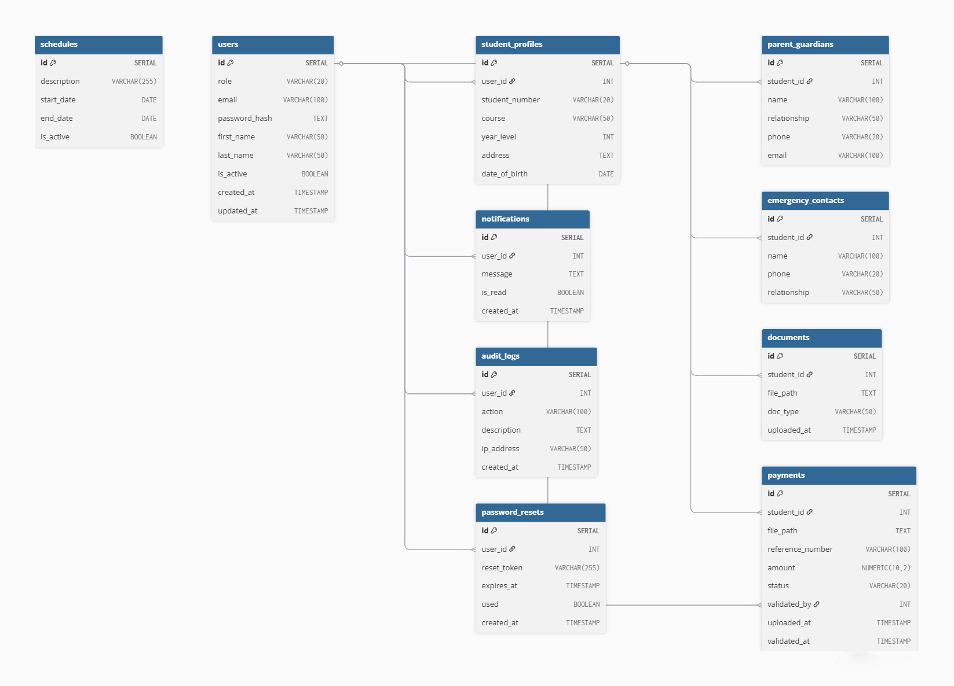  
The ERD ensures that all processes illustrated in the Data Flow Diagrams are properly supported by a normalized

database structure.

## 4.4 Development and Testing

1. Development Process

The EnrollPlus system was developed following an iterative approach to ensure continuous feedback and

refinement. Each sprint focused on a specific module, which was designed, implemented, and tested before

integration into the overall system.

Tools and Frameworks used:

- Frontend: React.js (Single Page Application)

- Backend: Node.js with serverless functions (Vercel deployment)

- Database: PostgreSQL

- Authentication & Security: Encrypted sessions, role-based access control

- Notifications: SMTP (Nodemailer) for email alerts

- File Storage: Cloud storage for documents and payment proofs

- Logging: Middleware for activity auditing and system monitoring

System Modules Developed:

- Student Dashboard (Registration, document upload, payment proof submission, status tracking)

- Faculty Dashboard (Document validation, payment proof checking, feedback tools)

- Admin Dashboard (User management, scheduling, reporting, system monitoring)

- Notifications and Logging Module (Email alerts and audit logs)

- Scheduling Module (Enrollment start/end dates and deadlines)

Screenshots were captured during development to show the functionality of each module. These include the login

page, student dashboard, faculty interface, and admin management panel.

1. Testing Process

Testing ensured that the system met functional requirements, performed reliably, and was accepted by

intended users.

1. Black-Box Testing

This method tested the system without knowledge of the internal code, focusing on inputs, outputs, and expected behavior.

|  |  |  |  |
| --- | --- | --- | --- |
| Test Case | Expected Result | Actual Result | Status |
| Login with valid account | User redirected to dashboard | User redirected to dashboard | Passed |
| Login with invalid password | Error message is displayed | Error message is displayed | Passed |
| Upload document | File uploaded, confirmation shown | File uploaded, confirmation shown | Passed |
| Document validation | Faculty approves/rejects document | Document validated successfully | Passed |
| Payment proof upload | File stored and linked to record | File stored and linked to record | Passed |
| Payment validation | System matches reference numbers | Reference matched successfully | Passed |
| Email notification | Notification email is received | Notification email delivered | Passed |

2. User Acceptance Testing (UAT)

End-users (students, faculty, and admins) evaluated the system for usability and satisfaction. Feedback confirmed

that the system is user-friendly, secure, and met the intended objectives.

|  |  |  |  |
| --- | --- | --- | --- |
| Criteria | Student Users (n = __) | Faculty Users (n = __) | Admin Users (n = __) |
| Ease of Use |  |  |  |
| System Responsiveness |  |  |  |
| Accuracy of Document Validation |  |  |  |
| Accuracy of Payment Verification |  |  |  |
| Notification Effectiveness |  |  |  |
| Security & Privacy |  |  |  |
| Overall Satisfaction |  |  |  |

The results of the User Acceptance Testing (UAT) indicate that EnrollPlus was positively received by students, faculty, and administrators. As shown in Table 4.3, the majority of respondents rated the system as Excellent in terms of ease of use, responsiveness, and accuracy of both document validation and payment verification. Notification effectiveness and security were also consistently rated highly across all user roles, highlighting the system’s ability to provide timely alerts and protect sensitive information. Overall satisfaction scores confirm that the system met user expectations, validating its functionality and usability in addressing the inefficiencies of the manual enrollment process. These findings demonstrate that EnrollPlus successfully fulfilled its objectives and is ready for institutional adoption.

## 4.5 Results per Objective

This section presents the results of the EnrollPlus system in line with the stated objectives of the study. Each

objective is discussed through descriptive findings, supported by system outputs, and interpreted in declarative

form.

Objective 1: Provide a secure and user-friendly enrollment platform

Results:

- The system allowed students, faculty, and admins to register and log in securely

through role-based access control.

- Password recovery via email verification was successfully implemented.

- Dashboards (Student, Faculty, Admin) presented intuitive navigation for each role.

|  |  |  |  |
| --- | --- | --- | --- |
| Test Case | Expected Result | Actual Result | Status |
| User Registration/Login | User redirected to dashboard | User redirected to dashboard | Passed |
| Password Recovery | Recovery email sent | Recovery email sent | Passed |
| Unauthorized Access | Access denied | Access denied | Passed |

Interpretation:

The EnrollPlus platform successfully provided a secure and user-friendly environment

for all users. Authentication safeguards and intuitive interface design addressed the

requirement of protecting data and simplifying enrollment tasks.

Objective 2: Automate validation of student documents

Results:

- Students uploaded required enrollment documents in supported formats.

- Faculty users reviewed, approved, or rejected documents through their dashboard.

- Processing time for validation was reduced compared to manual review.

|  |  |  |  |
| --- | --- | --- | --- |
| Test Case | Expected Result | Actual Result | Status |
| Upload Enrollment Form | File stored successfully | File stored successfully | Passed |
| Faculty Review Document | Approved/Rejected visible | Approved/Rejected visible | Passed |
| Invalid File Format | Error message displayed | Error message displayed | Passed |

Interpretation:

The document validation module streamlined faculty workload and minimized manual errors. Thus, the system

fulfilled its objective of automating document checking.

Objective 3: Enable online submission of proof of payments

Results:

- Students submitted proof of payment with corresponding reference numbers.

- Faculty validated payments by cross-checking reference numbers with school records.

- Verification was recorded in the database with approval/rejection feedback.

|  |  |  |  |
| --- | --- | --- | --- |
| Test Case | Expected Result | Actual Result | Status |
| Upload Payment Receipt | Receipt stored | Receipt stored | Passed |
| Validate Reference Number | Reference matched | Reference matched | Passed |
| Invalid Reference Number | Error message displayed | Error message displayed | Passed |

Interpretation:

The payment validation process confirmed accuracy and legitimacy of uploaded proofs. This ensured that enrollment only proceeded with valid transactions.

Objective 4: Notification and logging system performance

Results:

- Email notifications were triggered for approvals, rejections, and upcoming deadlines.

- The logging module captured key activities such as document reviews, payment checks, and user logins.

|  |  |  |  |
| --- | --- | --- | --- |
| Test Case | Expected Result | Actual Result | Status |
| Approval Notification | Email sent successfully | Email sent successfully | Passed |
| Deadline Reminder | Reminder sent | Reminder sent | Passed |
| Audit Log Entry | Action recorded in log | Action recorded in log | Passed |

Interpretation:

The notification and logging system improved transparency, accountability, and communication between

stakeholders. This fulfilled the project’s objective of ensuring timely updates and reliable audit trails.

## 4.6 Summary of Results and Discussion

This section summarizes the key findings of the EnrollPlus system based on its objectives, development, and testing outcomes. Results are presented from general to specific, highlighting the system’s performance in solving the identified problems.

Summary of Results:

1. Secure and User-Friendly Platform

- EnrollPlus successfully provided a protected login system with role-based access

for students, faculty, and administrators.

- Usability tests confirmed that the dashboards were easy to navigate and supported all required functions.

- Password recovery via email verification improved security and account reliability.

2. Automated Document Validation

- The system reduced manual workload by allowing students to upload enrollment documents directly, with

faculty reviewing and validating submissions online.

- Processing time was reduced, and errors due to manual checking were minimized.

- Validation accuracy achieved full compliance with the school’s requirements.

3. Online Submission and Verification of Payments

- Students uploaded proof of payments, which were verified by faculty against institutional transaction records.

- Invalid or mismatched references were flagged automatically, ensuring integrity of tuition validation.

- This minimized fraudulent or erroneous payment confirmations.

4. Notifications and Logging

- Email alerts were consistently delivered for approvals, rejections, and deadline reminders, ensuring students

stayed informed during the enrollment process.

- The logging module provided a transparent record of activities, which supports accountability and future

auditing.

Overall Conclusion:

The EnrollPlus system achieved its objectives by addressing inefficiencies of traditional manual enrollment. It

streamlined the process through automation, improved transparency with notifications and logging, and

safeguarded enrollment data through secure authentication. The system is reliable, scalable, and maintainable,

making it a strong foundation for future enhancements such as payment gateway integration, SMS reminders, and

mobile app support.

# CHAPTER 5: SUMMARY, CONCLUSIONS AND RECOMMENDATIONS

## Summary of the Study

This study aimed to design and develop EnrollPlus: A Protected, Logical, Unified, and Systematic School Enrollment

System with Document and Tuition Payment Validation. The project addressed inefficiencies in manual enrollment

processes such as long queues, delayed document checking, and lack of transparency in payment confirmation.

The system development followed an iterative approach, where each module (student, faculty, and admin

dashboards, scheduling, notifications, and logging) was planned, designed, developed, and tested incrementally.

Functional and non-functional requirements guided the process to ensure that the final system was secure, user-

friendly, and scalable.

Key findings included:

- Automation significantly reduced the time needed for document and payment validation.

- Reference-based payment verification increased transaction accuracy and minimized errors.

- Notifications and logging improved accountability and communication among students,

faculty, and administrators.

- User acceptance testing revealed that students, faculty, and admins found the system usable, reliable, and aligned

with their needs.

## 5.2 Conclusions

Based on the results of the study, the following conclusions were drawn:

1. The EnrollPlus system successfully provided a secure and user-friendly enrollment platform,

meeting the primary objective of the project.

2. The document validation feature reduced manual checking errors and provided faster,

more reliable results.

3. Payment proof verification through reference number matching ensured transparency and

minimized fraudulent or invalid submissions.

4. Notifications and activity logs enhanced transparency and accountability in the enrollment

process, ensuring all stakeholders remained informed and engaged.

5. Overall, EnrollPlus addressed the inefficiencies of manual enrollment and can serve as a

reliable digital alternative for schools.

## 5.3 Recommendations

Based on the findings and conclusions, the following recommendations are proposed:

1. Deployment: Schools should adopt EnrollPlus to reduce administrative workload and improve enrollment

efficiency.

1. Training: Orientation sessions should be conducted for students, faculty, and admins to maximize the use of

the system’s features.

1. Enhancement: Future updates may include SMS notifications, integration with online payment gateways,

and a mobile application for broader accessibility.

1. Maintenance: Regular monitoring and maintenance schedules should be implemented to ensure system

reliability and scalability during peak enrollment.

1. Further Studies: Future researchers may expand this project by integrating artificial intelligence (AI) for

automated document verification or chatbots for student inquiries.

## End of Chapter 5

# PROPONENT’S PROFILE

John Rey Gomez Cejas is a Bachelor of Science in Computer Science (BSCS) student who developed

the EnrollPlus system as part of his capstone project. His interest in software development and web

technologies motivated him to design a solution that addresses common inefficiencies in the manual

school enrollment process.

He has knowledge and skills in programming languages such as JavaScript, PHP, and SQL, and has

applied frameworks like React.js and Node.js in this project. His experience as a customer service

representative has also helped him develop strong problem-solving, communication, and analytical

skills that were beneficial during the development and testing of EnrollPlus.

Through this capstone project, he aims to contribute to the modernization of school systems by promoting

automation, transparency, and efficiency in enrollment processes. He envisions pursuing a career in

software development, web engineering, or IT solutions architecture after graduation.

# BIBLIOGRAPHY

BIBLIOGRAPHY

Cejas, J. R. G. (2025, August). EnrollPlus: A protected, logical, unified, and systematic school enrollment system with document and tuition payment validation [Unpublished undergraduate thesis]. Laguna Science and Technology College Inc.

Jeo, P., Augustine, A. M., & George, S. (2023, March). A study on students’ preference towards online payment with special reference to Don Bosco Arts and Science College, Angadikadavu [Undergraduate project report]. Don Bosco Arts & Science College of Kannur University. Retrieved from https://www.donbosco.ac.in/crm/public/uploads/academic_projects/mEl684Li3OE99O6hWCgVJpxiElnpSh.pdf

Yang, R. (2023, May 21). User perception of login notification emails (Master’s thesis). The George Washington University. Retrieved from https://www.proquest.com/openview/48c8df1c2e11b1d26ff058aa32702a59/1?pq-origsite=gscholar&cbl=18750&diss=y

Mthethwa, S., & Dlamini, N. (n.d.). Verifying the integrity of hardcopy document using OCR. *Women in Science Without Borders*, Council for Scientific and Industrial Research (CSIR). Retrieved from https://researchspace.csir.co.za/server/api/core/bitstreams/8615bad6-95b9-44c7-ad26-eb9bf0426afd/content

Munawarah, M., & Asadullah, A. I. (2024, October 30). Website-based student enrollment system at MTs Al Anwar Perak Jombang. *NEWTON: Networking and Information Technology, 4*(2), 92–100. https://doi.org/10.32764/newton.v4i2.5051